Remy Lagrois

1. None of the randomized averages had a difference of more than 2.1 which is not greater than the difference in the groups from the study (4.1). The average of the magnitude of difference between all the randomized groups is 1.15 which is quite a bit lower than even the largest difference. This supports the study’s findings that there is a difference when motivation is intrinsic. (Randomized groups are in the excel file)
2. 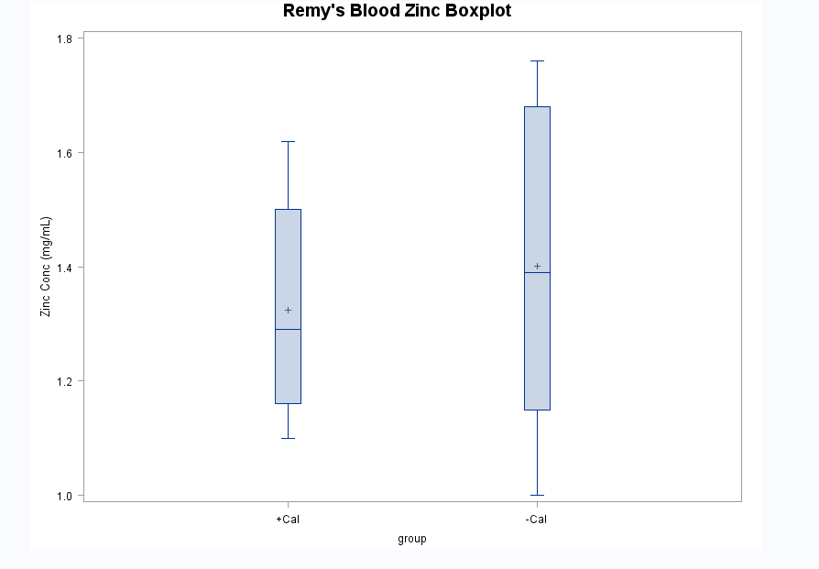 The median for the + Cal group is slightly lower than the –Cal group. However, the largest difference between the two groups is the range of blood zinc concentrations. The variance and overall range of the +Cal group is much smaller than the –Cal. While receiving calcium may have had the slight effect overall of lowering zinc concentrations it seems to play a larger role in keeping zinc concentrations at a consistent level.

Bonus question next page

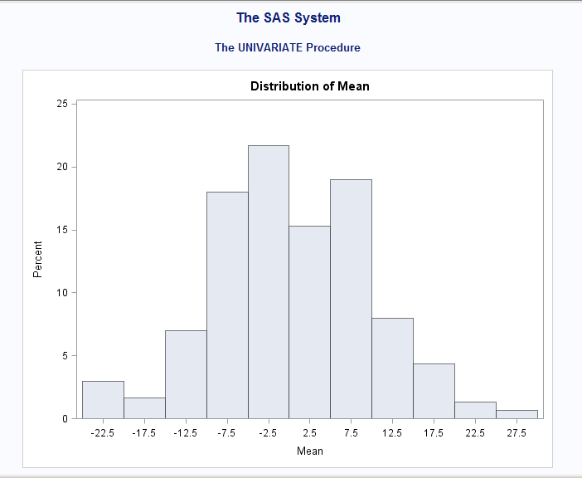This is the mean distribution for 300 runs of randomization. The mean difference for the actual study data was ~17.5.

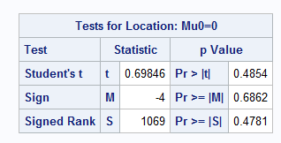Here are the p-values for the associated data. While the average is somewhat to the margins of the distribution it is not large enough to show a statistically significant connection between gender and SSHA scores.